Experiment 1 - HPC Lab on WSL Ubuntu

Task 1 - HPC Environment Setup
Step 1: Open Ubuntu (WSL)
Step 2: Update Packages
sudo apt update
sudo apt upgrade
Step 3: Install GCC
Check whether GCC is already installed.
gcc –version
Step 4: Check OpenMP Support
Create a file
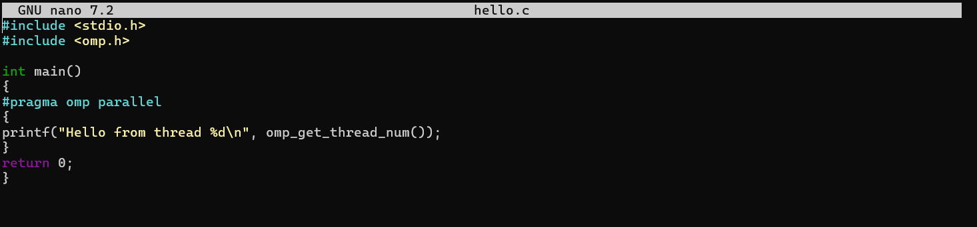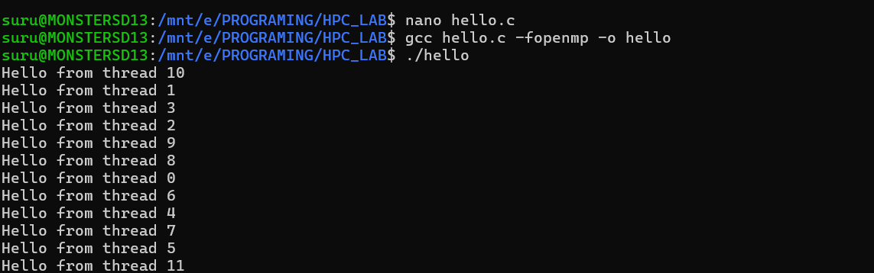
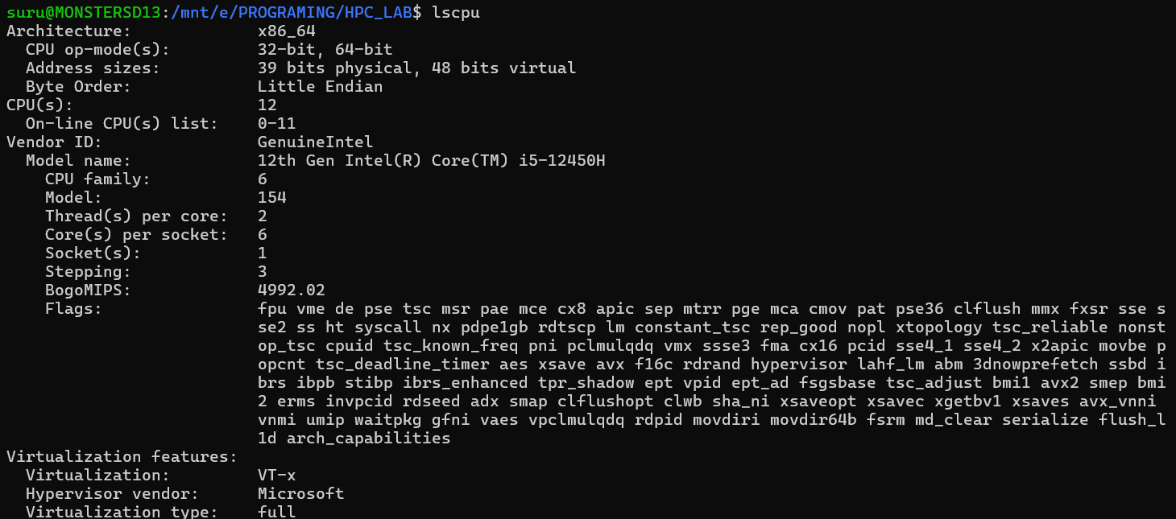
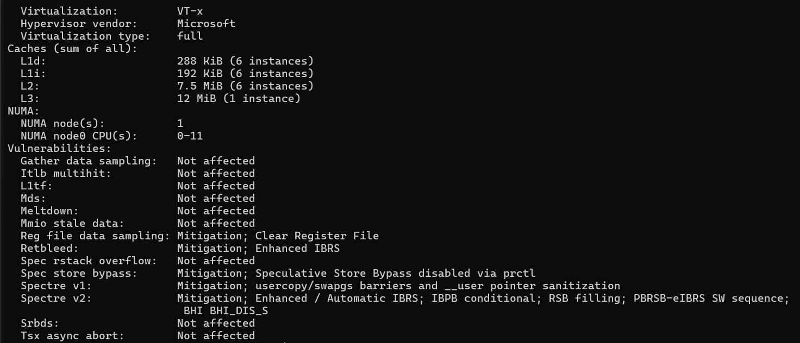

Task 2
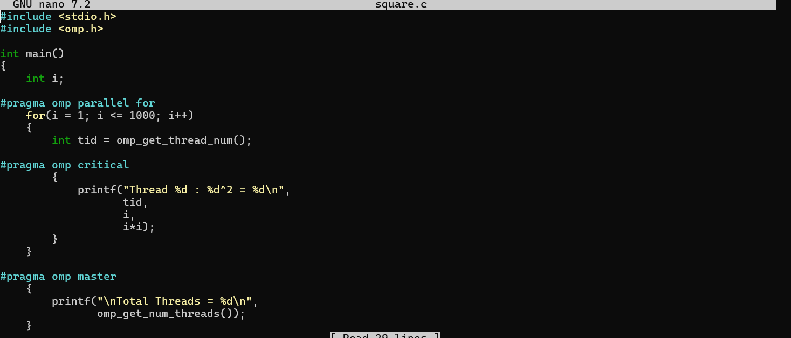


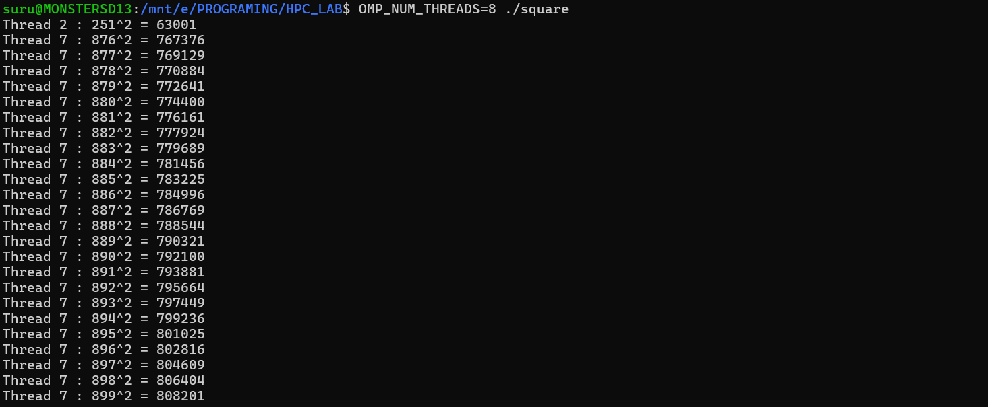

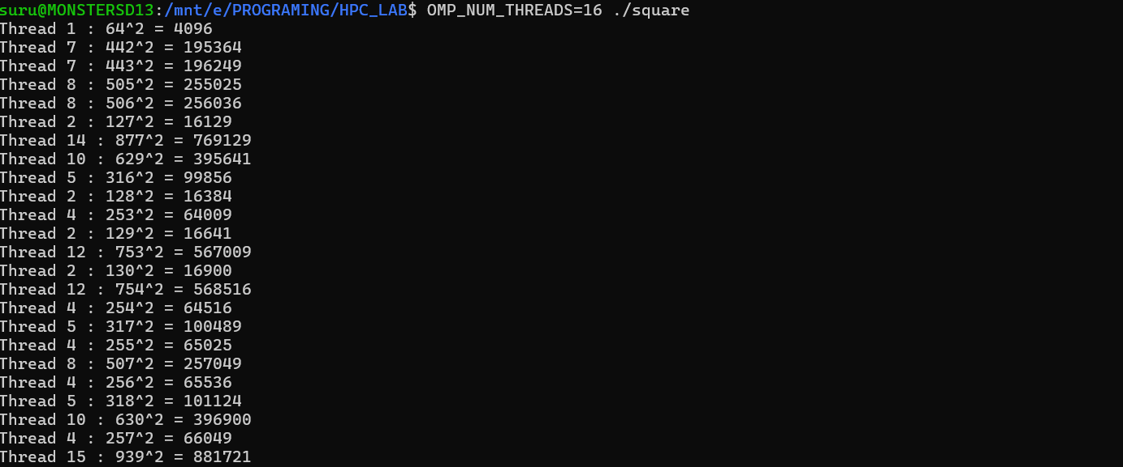
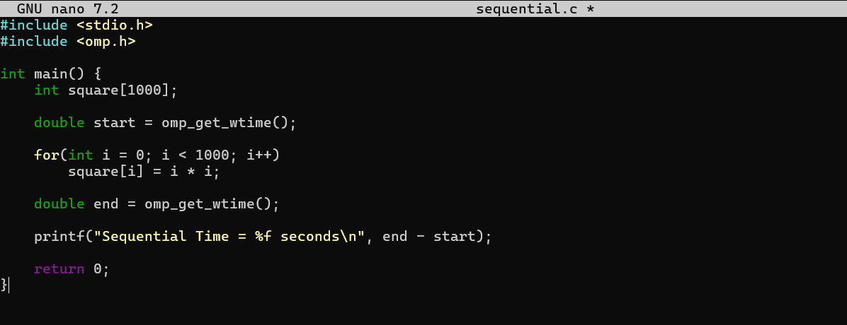
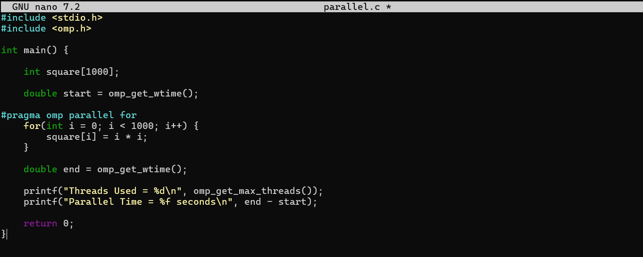
Threads | Sequential Time (s) | Parallel Time (s) | Speedup
2 | 0.000042 | 0.000030 | 1.40
4 | 0.000042 | 0.000020 | 2.10
8 | 0.000042 | 0.000015 | 2.80
16 | 0.000042 | 0.000013 | 3.23
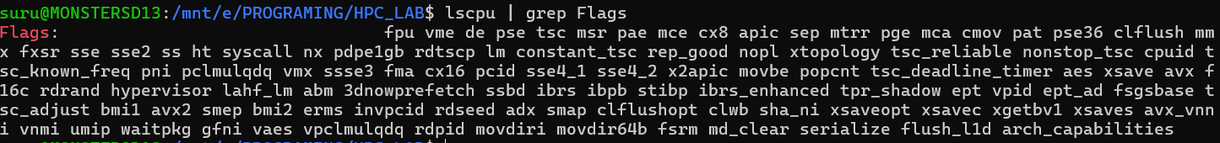
Parameter | Value
Physical Cores | 8
Frequency | 4.40 GHz
SIMD Width (AVX2 Single Precision) | 8
Operations (FMA) | 2
Final Answer
$$\boxed{563.2\text{ GFLOPS}}$$

